1. **What is the concept of AOP?**

AOP consist of the following concepts:

1. Aspect class:

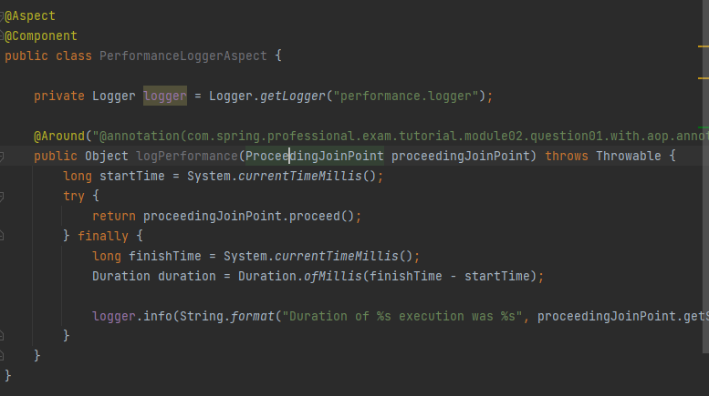

1. Advice: where the code been injected :

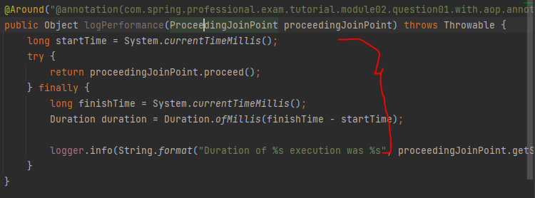

1. Pointcut expression which match the jointpoint:

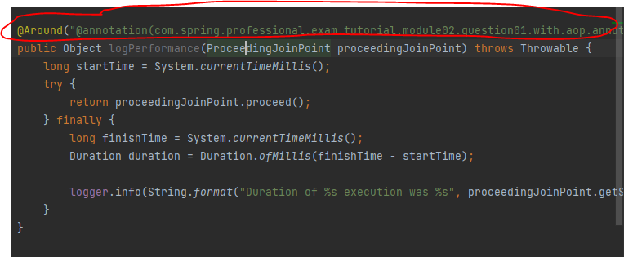

1. Jointpoint is the method execution:

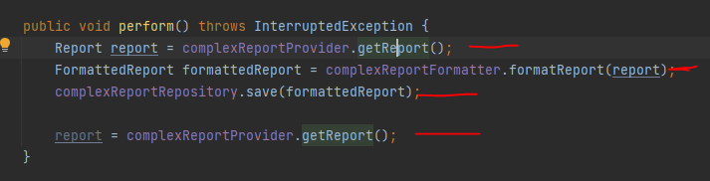

1. The advice code will be injected whenever pointcut expression matched , example for the following code:

We have pointcut ‘@annotation(com.spring.professional.exam.tutorial.module02.question01.with.aop.annotations.PerformanceLogger’ and this PerformaceLogger is a custom annotation class:

1. For the jointpoint we should annotate it with @PerformanceLogger to trigger the AOP:

1. **What is the problem that AOP solve?**

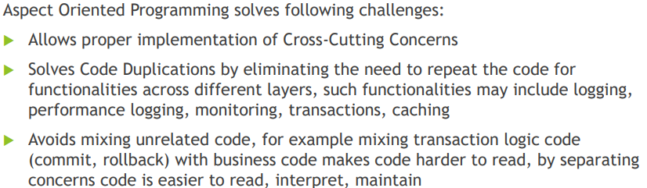

1. **Name three typical cross-cutting concerns?**

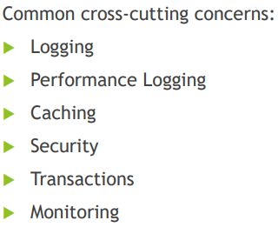

1. **What is the pointcut , joint-point and advice , an aspect and weaving ?**



1. **Point-cut expression examples?**

1. **What is the advice?**



Types of point-cut:

1. Inline point-cut (point-cut and advice in the same method):

1. Outline point-cut (point-cut and advice in two different methods):

1. **What is Aspect?**

Aspect **must** be annotated with @componant

1. **What is the weaving concept?**



1. **Types of weaving?**

Note: that spring use runtime weaving,

Spring will use CGLIB proxy or jdk proxy to implement the Aspect:

See the following example , currencyService is class (not interface) so spring will use cglib proxy to create a reference of this class by **extending** from the class.

For currenciesRepository spring will use jdk proxy bcoz its interface so it will create a reference of the object itself.

In the debug mode we can see:

For jdk it container the reference of the original class:

For cglib it will just extend the original class:

Note: its good to take a look at module02-q02

1. **How does spring solve/implement the cross-cutting concern?**

1. Graphical user interface, text, chat or text message

   Description automatically generated**How jdk proxy works?**

Spring will implemet the interface and it will has a reference of the target class (in the example the target class is EmployeeRepositoryImp) and in the new class it will pass the target in the constructor,

So in this example the new class is EmployeeRepositoryJdkProxy that has a reference to the target class which is EmployeeRepositiryImp .

In the Client Side it will call the EmployeeRepositoryJdkProxy instead of the original class.

So lets say when the client call findEmployeeById in EmployeeRepositoryJdkProxy then this will trigger the code that should be called before/after the findEmployeeById at the target .

EmployeeRepositoryJdkProxy has a method ->

findEmployeeById()

call before -🡪 do something

call original method from the target class which is

targetClass.findEmployeeById()

call after 🡪 do something

so under the hood spring will create something like this:

It will implement the interface and it will has the reference from the target class.

And it will invoke the code from the target.

1. **How cglib works?**

In cglib it will extend the class and it will override the methods:

And the client will call EmployeeRepositoryCGLIBProxy instead of the original class.

So this is what spring do under the hood for the cglib:

It will extend from the original class and will override the methods

And it will invoke the method from the original class by calling super.<method name>

To force spring to use cglib:

1. **What are the limitation of using jdk and cglib proxy?**

Even tho if we try to invoke the private method it will not be proxied :

1. **What is the types of advices?**

Please look at module02-q05 its important.

1. **What should you use to catch exceptions?**

1. **How to enable the detection of @Aspect annotation?**

1. **What is the point-cut expression types?**

1. Text

   Description automatically generatedExecution expression type:

The execution for the first method @Before will match all public modifier access that return NOT int and ALL sub class (..) for HelloBean that starts with say* and accept String as first param and anything for next param, as we saw here we didn’t specify the throws coz its optional.

For the @After execution we match all access modifier (coz we didn’t mention the access modifier so to will match all by default) and the method that will return void and all class and subclass under HelloChildBean and the name of the method validateName and accept any number of param and throws exception io.IOException.

1. Within expression:

For the first method it will match all packages and sub-packages and the class name is HelloChildBean.

For the next method it will match all sub-packages with any class name within com package.

For the third class it will match all sub-packages that start with Hello and end with Bean

1. Arg expression type:

1. Bean expression type:

This will match **all the methods** in the bean.

Lets say HelloCildBean has 4 method then the aspect it will be called 8 times for before and after.

1. This & target expression types (important):

Before we explain this lest take a look how cglib and jdk work:

For jdk:

For EmployeeRepositoryIml it’s the ‘target’,

And EpmolyeeRepositoryJdkProxy is the ‘this’

Lets take a look on this example:

ITaxBean is the interface

TaxBean1 is implementing ITaxBean (which mean it will use jdk).

TaxBean2 not implementing any interface (which will use cglib).

Lets take a look on the aspect class:

For thisTaxBean1Example1() it will be called bcoz ‘this’ is actually implementing ITaxBean interface.

For thisTaxBeanExample2() it will not called bcoz this is NOT type of TaxBean1 , its jdk that use the TaxBean as **delegation only**, that’s why for thisTaxBeanExample2() its not been executed.



For targetTaxBeanExample1() it will be called bcoz the target in jdk is type of ITaxBean coz its implementing it already.

For targetTaxBean1Example2() it will be called bcoz the target is match TaxBean1 coz its jdk.

For Cglib:

It will extend from the target that’s why both this & target will be matched for cglib.

1. @annotaion expression type:

For @annotation will works on top of the method only , not class.



And the result will be:

1. @args expression type:

And this interface used on top of the class:

And this class used over here:

And the results will be:

1. @within expression type:

And the custom annotation:

And its annotated-on top of this class:

And the results will be:

It will be 2 bcoz inside this class there are two methods

1. @target expression type:

It will be executed 2 times also bcoz cglib proxy and the target that has been created is also annotated with this custom annotation.

1. **What is the logical operator for pointcut?**

1. **What is the joint-point args?**

It used to retrieve some info about the join-point.

1. **What is ProceedingJoinPoint?**

Please take a look at module02-q09